**Assignment IU 03-2 Submission**

**Train a model with the Azure Machine Learning Designer**

Azure Machine Learning Designer offers a user-friendly, drag-and-drop interface that simplifies the process of creating, training, and comparing machine learning models. It's a powerful tool for data scientists and machine learning engineers, enabling them to build and test models with ease.

Importance:

Accessibility for Non-Programmers: Azure Machine Learning Designer doesn't require extensive coding skills, making it accessible to non-programmers and reducing the entry barrier for machine learning projects.

**Rapid Model Development:** The drag-and-drop interface streamlines the model creation process, allowing data scientists to experiment with different algorithms and configurations quickly.

**Experiment Comparison:** Designing workflows for multiple algorithms side by side facilitates model comparison. This is invaluable for selecting the best-performing model for a specific task.

**Visual Representation:** The Designer provides a visual representation of the workflow, making it easier to understand and communicate complex machine learning pipelines to stakeholders.

**Integration with Azure Services:** The Designer seamlessly integrates with Azure services, data sources, and compute clusters, streamlining the end-to-end machine learning process.

**Reusability:** Custom components created in Designer can be reused in multiple pipelines, saving time and effort.

**Error Debugging:** In case of pipeline failures, the Designer helps pinpoint which component failed and provides error messages for debugging.

**No Infrastructure Management:** Users can focus on model development, as Azure handles the infrastructure and scaling automatically.

**Experiment Tracking:** Experiments in Designer are tracked, logged, and can be visualized in the Azure Machine Learning workspace, supporting reproducibility and auditing.

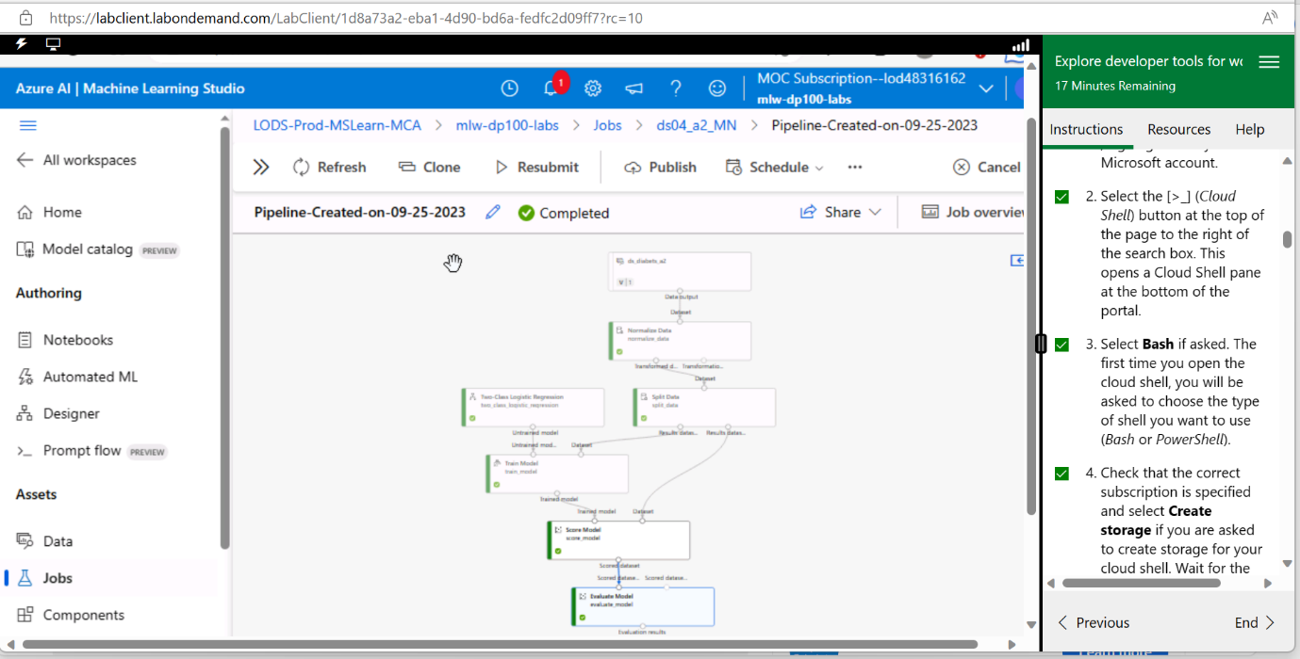**Completed Pipeline**

**Evaluate Matrics**

**In conclusion,** Azure Machine Learning Designer is an essential tool for data scientists looking to build machine learning models efficiently. It promotes rapid model development, experiment comparison, and ease of use for non-programmers, all while providing access to Azure's powerful infrastructure and services.